1. Soil C pool and rate data was from Table 1 (page 497).

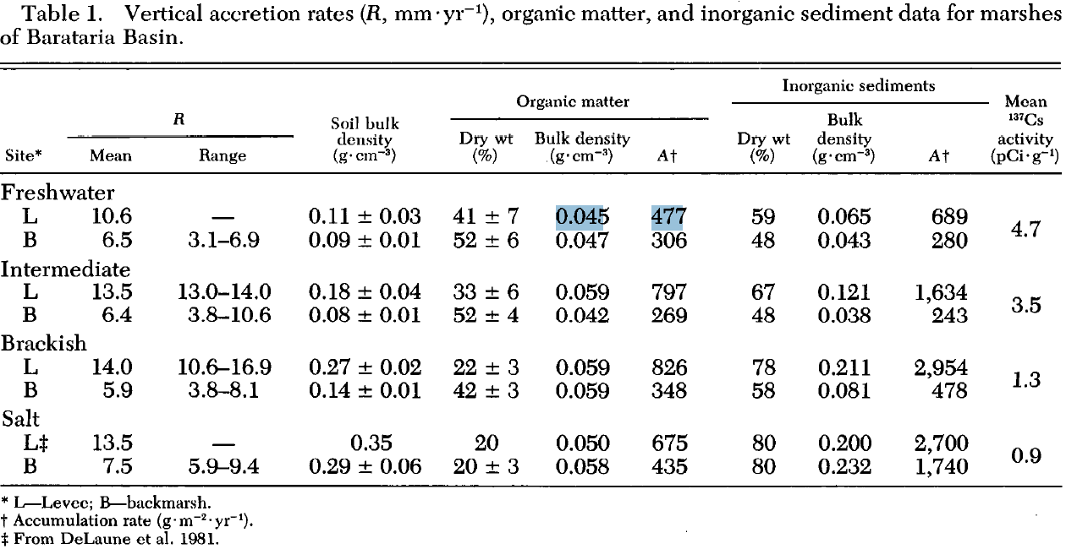

2. Meng did not find the name for the species “*Eleocharis sp.*” on USDA website.